TIM 155: Problem Set 4

Due Tuesday, August 23, before class is over.
It can be turned in by hand or via email to bhaddad@ucsc.edu

- According to GEA, Ch. 11, after several years of decline, the cost of windpower increased between 2002 and 2009. Focusing on onshore systems, how much did it go up in cents per kWh? What reasons were suggested for the rise? Based on this recent behavior in the cost of wind power, do you think costs will go up or down over the next 10 years? Base your answer on the factors you listed above for the recent rise in costs – are they temporary or long-term trends in your opinion? Will other factors outweigh them? (1 point)

- Review the Interview Notes found in the HW reading list. Part way down is a section on how to determine how many panels a solar system needs. The first half includes what Prof. Haddad could quickly jot down during his conversation with the solar installation expert. He then added an extra step to the calculation to include the TOF, or tilt-orientation factor. Use that equation for this question. The SAM model also calculates the number of panels needed for a solar installation. Use the “by hand” approach presented in the SAM Help document. Your job is to compare the SAM approach to the Installer/Prof. Haddad approach. Are they identical? Does one approach have additional factors? Explain in detail any methodological or input differences. (Hint: there is some useful explanation and links to more details starting at page 125 of the SAM Help document on our class website.) (1 point)

- Deborah, who kindly agreed to be interviewed, has five years professional experience in the residential solar industry. She had not heard of the SAM system. Based on your analysis of question 2, do you think Deborah or her competitors would improve their service if they used the SAM model for residential PV? Explain. (1 point)

- Elsewhere in the interview notes is Deborah’s reference to PG&E’s “110% rule.” This is industry “shorthand” for a rule built into PG&E’s net metering rate structure. First explain what net metering is. Then present in your own words what the “110% rule” is. (1 point)

- Now open the SAM system and point out whether/where evidence of the “110% rule” is found. For residential-solar, select PG&E’s Territory T Rate E-7. When it loads, examine the rate structure. Explain what buy rates and sell rates are, and point out any evidence of the “110% rule.” (1 point)

Water Ratemaking

- Professor Haddad’s lecture slides provide 8 objectives of water rate making. In our water ratemaking reading folder, there is a file called Water_Pricing_Objectives. The reading is a professional product from Raftelis Financial Consultants, a company that specializes in water ratemaking. Please compare Professor Haddad’s list with the Raftelis document. List any objectives that you think are identical. Then list ratemaking objectives one list includes and the other doesn’t. Then list any objectives that overlap, and explain how the objectives overlap/differ slightly. (1 point)

- Based on your answer to #6, generate a new comprehensive list of ratemaking objectives with brief explanations. Choose what you believe are the best and clearest terms and explanations of the objectives. If you are not satisfied with either of the lists, then add your own additional terms and explanations. At the end of each objective/explanation, put in parentheses where it came from, such as (Haddad), (Raftelis), (hybrid), (original). (1 point)

- Use the list you generated in Question 7 to select what you believe would be the three most important objectives for the mutual water company described in class and on the Background page of the homework #4 Workbook. Then generate a list of three other objectives that don’t overlap with the ones you chose. Fill in the grey-shaded lines with the two different lists. (1 point)

- Even though your task as a consultant is to generate a rate plan, your client won’t be satisfied if the company’s budget problems cause the rate plan to fail. Review the target budget and the capital plan and decide if you think they are reasonable or if they will not meet the needs of the region over the next few years. If you are not satisfied with the budget as written, cut and paste the proposed budget and proposed capital plan from the Background page onto the Review Expense Estimates page and then revise the spreadsheet so the budget is more realistic. Explain below how and why you changed the budget. Use this new budget going forward. If you think the budget is fine, say so and proceed to the next question. (1 point)

- Now it is time to generate two different rate plans. One is meant to satisfy the set of objectives you personally identified and the other to satisfy the alternative list. Refer to our lecture powerpoint slides and use the list of rates, charges, and fees to select which ones you believe will help you create a rate plan consistent with the objectives. List each set on the appropriate page. (Hint: since the objectives are different, it is very likely that the combination of rates, fees, and charges will be different.) (1 point)

- Next list the variables that you will need to quantify to generate a rate plan. (E.g., one would be RTS Charge. Another might be New Membership Fee. Also refer to the equation we wrote on the chalkboard in class.) (1 point)

- Now build a spreadsheet model that has cells where you can enter values for the variables you listed in 11, as well as equations that turn the values into the total budget figure you identified in Question 4. Using the model, generate rate plans for both sets of objectives. (1 point) Here are some suggestions:

- you will need the information on number of members of each use category (unmetered, 1” metered, 2” metered) from the background page.
- You will need to estimate how many, if any, new members (e.g., new houses) the company will have each year, as well as how much they will be charged to become a member and be hooked up to the system.
- If you are not comfortable with Excel programming, please Professor Haddad and I’ll give you some guidance (or seek other assistance!).
- You may need to try different combinations and levels of rates and fees until you arrive at or near your budget target.
- Present your rate plan clearly so your client (and grader) can understand what you have proposed.

- Having generated two proposed rate plans, explain how they differ and how each one is consistent with its own set of objectives. (1 point)

Groundwater Model Questions

Part 1: Water Budgets

14. Our (alas pretend) consulting firm Energy and Water Analytics is conducting a watershed assessment for the Arroyo Seco watershed (Figure 1) in southern California. The water district needs to calculate its average change in surface water storage in order to plan for future growth in the region. From the initial research, you have gathered the following estimates in the table below. The water district also informed you that the region does not export any water.

Remember the water budget equation we reviewed in class:
INFLOW = OUTFLOW +/- CHANGE IN STORAGE
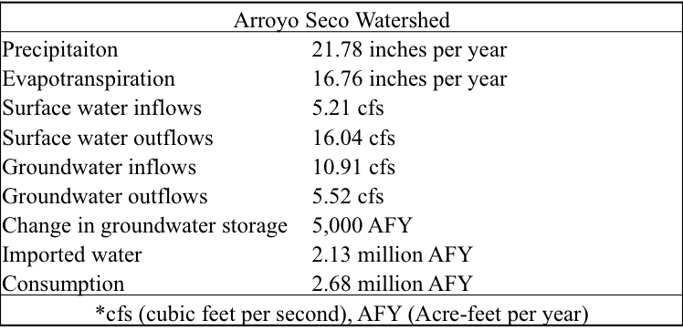

Calculate the average change in surface water for the region and report it in AFY (Acre-feet per year). Please show your work. Explain what your result indicates in terms of the sustainability of water availability in this region. (4 points)

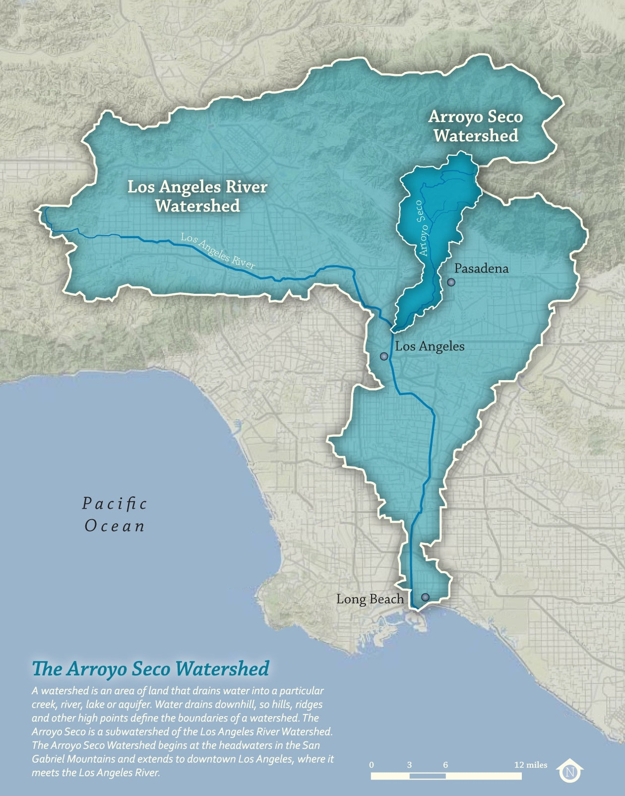
Figure 1: The Arroyo Seco Watershed. Image credit: The Arroyo Seco foundation.

Part 2: Groundwater withdrawal

Before answering the question below, complete all the steps outlined in the “Instructions” tab of the excel sheet called “HW9.1_YourNameHere.xlsx” Also refer to the “Radial Flow to Wells Reading.pdf” for additional information.

15. Examine the two distance versus drawdown plots that were generated from your calculations using the Theis equation. Compare the number of data points necessary to define the shape of the cone of depression on the two plots. Which one type of plot takes fewer points, the distance versus drawdown on the arithmetic axes or on the semi-logarithmic axes? Is there an advantage creating one of these plots compared to the other type of plot? (1 point)

16. Describe how the shape of the cone of depression changed between 1 year of pumping and 40 years of pumping. (1 point)

17. How much deeper is the cone of depression after 40 years of pumping the fire-protection well compared to 1 year of pumping? Is the change uniform across the radial extent of the cone of depression? (1 point)

18. After review of the calculations for the fire-protection well previously described, the Nuclear Regulatory Commission mandated that there must be 2.6 million gallons of water a day (mgd) available for emergency fire fighting. How will this change the demands on the fire-protection well and what would be the drawdown created after 40 years (worst case scenario) at the Crown-Zellerbach well? (1 point)

